Sayana® Press Contraceptive Injection
Patient information leaflet

Bilbrook Medical Centre

This information leaflet is for those who are planning to use Sayana® Press and have been seen and advised by a Health Care Provider at Bilbrook Medical Centre.

You have been counselled on Sayana® Press as a contraceptive and have received direction and observation to give yourself a Sayana® Press injection before injecting on your own.

Sayana® Press protects you from pregnancy for 13 weeks.
Although it can still be effective if administered up to a week late, it is important that you receive your injection every 13 weeks so not to put yourself at risk of pregnancy.

Once you have successfully injected yourself under supervision, you will be given a small sharps bin and we will issue repeat prescriptions of Sayana® Press for you. We recommend contacting us at least 4 weeks before your next injection is due to make sure your prescription is ready in time. Bear in mind that your community pharmacy may need a few days notice to order the injection in.

A reminder text message can be sent to your mobile phone. Text SELF to 83311 with the date of last injection (for example SELF27.01 for January 27th) or follow this link www.sayanaanswers.co.uk/staying-on-track

If you are late giving yourself Sayana® Press, please contact us for advice.

Please contact us as well if you develop a serious or persisting injection site reaction on your skin (redness, itchiness, swelling, scarring or a dimple) and do not repeat your injection before having this chat.

We recommend a review with ourselves once a year to make sure that the Sayana® Press injection remains the best method for you. If you develop a serious medical problem like cancer, a heart attack or a liver problem in the meantime: please check with your us or a Sexual & Reproductive Health Clinic if you need to change your contraceptive method.

As the injection, when used continuously for years, could thin your bones, it is particularly important for you to eat a well-balanced, calcium rich diet, do regular weight-bearing exercise, get outdoors and avoid excessive alcohol and smoking.

See this link for more information: https://nos.org.uk/about-osteoporosis/prevention-are- you-at-risk/a-balanced-diet-for-bones/

Should you plan a pregnancy soon: we recommend stopping Sayana® Press one year before trying to get pregnant and using a different contraceptive method after that.

Videos to show or remind you how to self-inject can be found at:
www.sayanaanswers.co.uk/guide-to-self-injection and
on YouTube at: https://www.youtube.com/watch?v=hi2o-mlQJjc

Self-injection of Sayana® Press

- Make sure you have the following items ready: Sayana® Press injector in an unopened, undamaged pouch at room temperature, clean cotton wool, tissue or antiseptic wipe and a container for the used injector (small sharps bin).

- Check the expiry date of the Sayana® Press injection on the box.

- Wash your hands.

- Choose a suitable area for the injection – either abdomen (tummy) or the front upper thigh. Avoid any scars or skin affected by a skin condition.

- Clean your skin with water and cotton wool or antiseptic wipe (if available).

- Carefully remove the Sayana® Press from its package and inspect it. Discard if there is no gap between the end of needle shield and port, or the injector is damaged. Discard if the needle shield has come off or is missing.

- Next you need to mix the medication. Hold injector firmly by the port; shake well for at least 30 seconds. Discard if the liquid in the injection does not appear white and uniform or there is any leakage. Repeat mixing if there is a delay in giving the injection.

- Get the injector ready by holding the injector firmly by the port. Do not squeeze the reservoir.

- Hold needle shield with your other hand. Push needle shield towards port to activate the injector until it stops and you hear a click. Then remove needle shield and dispose of.

- Self- injecting. Gently pinch a large area of skin, insert needle at a right angle (90°) so that port just touches skin, squeeze reservoir slowly to inject medicine (5 – 7 seconds).

After the entire dose has been injected let go of your skin and pull the needle out. Do not replace needle shield. Press area lightly with cotton pad or antiseptic wipe.

- Check the amount of medication left inside the reservoir. It is normal for traces of medication to be left inside the reservoir, showing a white rim. Please get advice from a health care professional if any medicine has leaked or if you have any other concerns. If less than a full dose has been given use a different contraceptive method (like condoms as well) until the next injection is due.

Do not inject another dose.

- Dispose of used injector in sharps bin provided. When nearly full, this bin can be returned to our practice for disposal.

- Write down when you injected your Sayana® Press and when next due your injection. You are advised to use either mobile SMS reminder or staying-on-track link (see above how to do this).

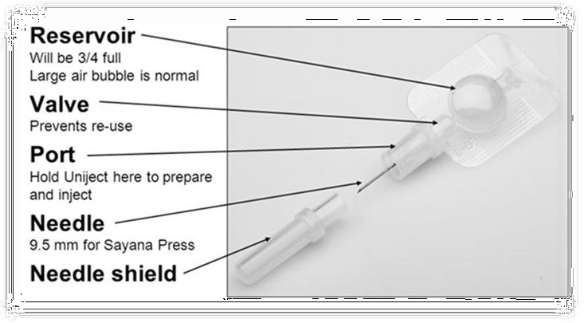
Figure 1: Parts of the Sayana® Press injector
Follow Up

Your next Sayana® Press injection is due on / /

 Your next Sayana® Press injection will be done by yourself at home.

 Your next Sayana® Press injection will be done by yourself but supervised by a health care professional.

Please contact her if you have not heard from her four weeks before you are due for your next injection.

Date ………………………………………………………………

Time ……………………………………………………………...

Place………………………………………………………………

If you are unable to make it to your appointment, please let us know as soon as possible, in order that we can use the slot for someone else.

If you require further information or want to discuss a change in your medical history or in the medicines you are taking, please contact us.

Further information can also be found at: www.sayanaanswers.co.uk

Bilbrook Medical Centre
Brookfield Road
Bilbrook
WV81DX

Telephone line: 01902 847313

Website: https://www.bilbrookmedicalcentre.nhs.uk/

Produced: May 2021 Review: May 2023

